Secure Cloud Deployment Lab Report

Thomas Adkins
BAT Program, Lone Star College
ITCS-3330 W005 1 Applied Database Management
Dr. Watson
April 5, 2026

Secure Cloud Deployment Lab
Task 1: Entering the Instance (Linux Proficiency)
- Accessing the Cloud Node: Use the incus shell command to enter the gsoc-node container. This establishes a root shell session inside the virtualized environment allowing for direct interaction with the container’s operating system. The prompt will change from the host system to reflect the container context. (see figure 1)
Figure 1:
Command to enter the node
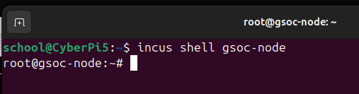
Task 2: Hardening the Node (Security)
- Installing nala: Install nala using apt for a faster, more comprehensive version of apt with more features. (see figure 2)
Figure 2:
Command to install nala (generally better apt alternative)
- Implementing a Linux Firewall: Ensure that the system is fully up to date by running a full-upgrade with nala, then install the Uncomplicated Firewall (UFW) to secure the container. (see figures 3-4)
Figure 3:
Command to fully upgrade the node then install the UFW
Figure 4:
Shows that the command completed successfully
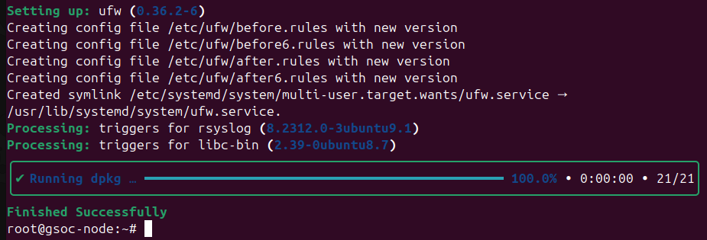
- Firewall Configuration: Explicitly allow port 3306 to enable MySQL access while all other unsolicited traffic remains blocked. Then, enable the firewall and check its status to ensure that it is now active. (see figure 5)
Figure 5:
Commands to explicitly allow port 3306, enable the firewall, and check its status
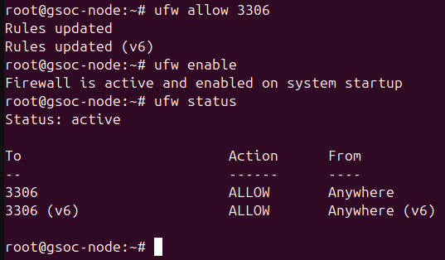
Task 3: Cloud Database Installation
- Installing the Database Engine: Use nala to install MySQL Server inside the container. This creates an isolated database environment independent of the host system, ensuring that database services are confined to the cloud node. (see figure 6)
Figure 6:
Command to install MySQL server inside of the node.
Task 4: Data Migration (The File Push)
- Create a Backup: Use the mysqldump utility to export the GSOC_Security database into a SQL file. This file serves as a portable backup that can be transferred into the container environment. (see figure 7)
- Transferring the Backup File: Use the incus file push command to transfer the backup file from the host system into the container’s root directory. This simulates data migration into a cloud-based environment. (see figure 7)
Figure 7:
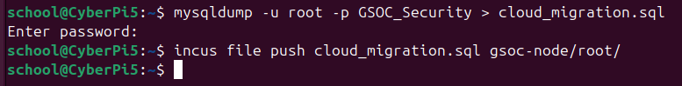
- Creating the New Database: Before the SQL backup file can be successfully executed within the node, the database itself must be created. Within the node, start MySQL and create the new database, then exit MySQL. (see figure 8)
Figure 8:
Commands to enter MySQL and create a new database.
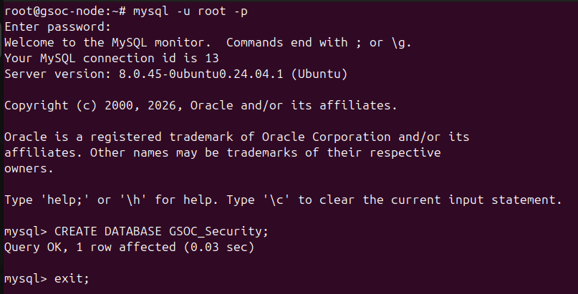
- Importing the Database: Execute the SQL backup file inside the container using the MySQL client. This restores the GSOC_Security database to the new database that was just created within the cloud node, completing the migration process. (see figure 9)
Figure 9:
Final command to restore the backup within the node using the backup file.
Task 5: Personal Reflection (Architectural Analysis)
Running the database inside of an incus container is more secure than directly on the Raspberry Pi’s main OS because it introduces an additional layer of isolation. The container acts as an isolated environment which means that even if the database is compromised, the attacker should in theory be confined to that container only, rather than having access to the host system. Additionally, firewall rules can be configured on the the container with rules that apply specifically to the containers needs rather than relying on the host systems firewall rules, which might not have the same needs or security levels as the container would require.
This architecture simulates a public cloud environment because the database is no longer running directly on the physical hardware, but instead on a virtualized instance that needs to be connected to. The process that was used to push the backup file into the container for restoration was also extremely similar to how data is migrated to cloud instances in real-world deployments.

